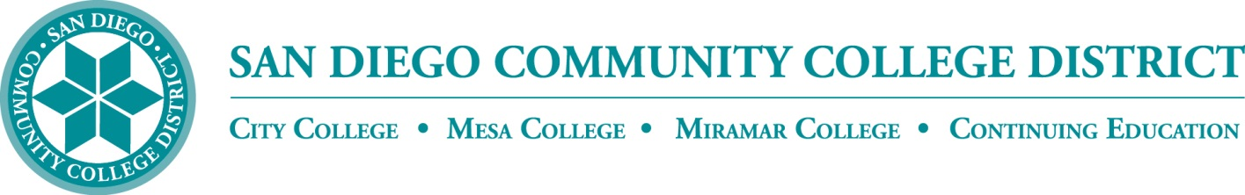**AP 5040**

**Administrative Procedure**

Chapter 4 – Academic Affairs

**AP 5040 LIBRARY AND LEARNING SUPPORT SERVICES**

**References:**

Education Code Section 78100;

Civil Code Section 1798.90 (Reader Privacy Act);

WASC/ACCJC Accreditation Standard II

Under supervision of the appropriate administrator, each college shall establish and maintain library and learning support services. The college libraries shall follow the standards set out by the American Library Association to ensure the greatest accessibility to materials and resources. The libraries shall provide students, faculty, and staff with materials and resources that support their instructional needs. The libraries shall align their services with the mission, vision, and values of the District and college they serve.

The librarians at each college shall develop and maintain guidelines regarding access services, collection management, instruction, reference, and technical services.

|  |  |
| --- | --- |
| **Date Approved:** |  |
| *(This is a new procedure)* |  |